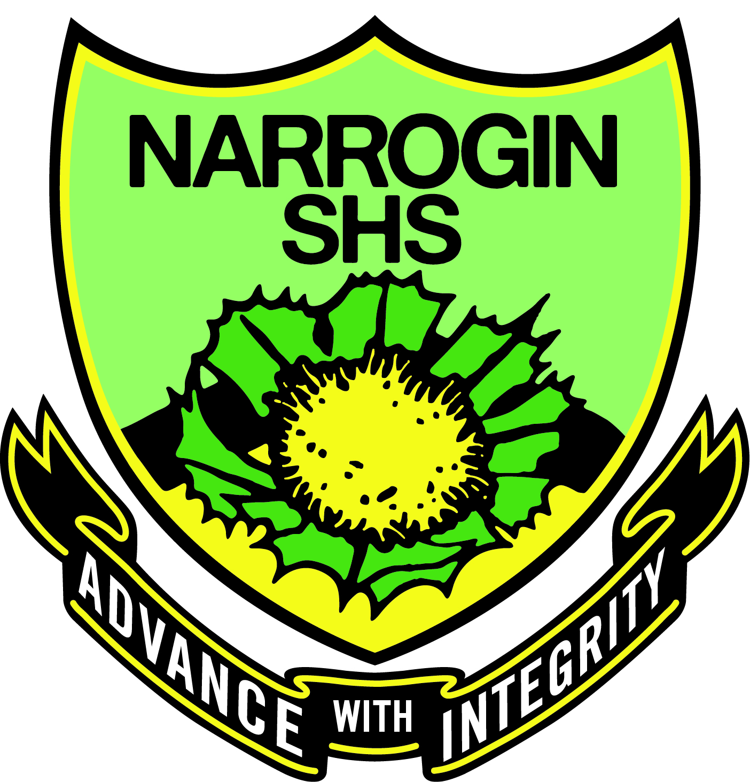

Name: _______________________ Year: ______

My Health Teacher is: ________________________
My PE Teacher is: ___________________________
My Academy Teacher is: ______________________

Narrogin Senior High School
Gray Street NARROGIN WA 6312
Tel: (08) 9881 9300

Health & Physical Education

Excursion Permission Form 2020

Dear Parent/Guardian,

Your child will at times, be required to leave the school grounds in order to participate in various curriculum activities relevant to their course of study. We therefore seek your approval for transportation arrangements that need to be met by the school.

In all cases, the activities will be based in or in the near vicinity of town. In all circumstances your child will travel by school bus or will walk/run/cycle under supervision of school staff. Activities may include, but are not limited to: activities at the recreation centre (including swimming), trips to local primary schools for coaching purposes, visiting aged care facilities, the hospital, etc.

If you find these arrangements acceptable, please complete below and have your child return this form to their Health & Physical Education teacher or Front Office.

If you have any concerns, please contact me on 9881 9331 or 0418 813 968. If this form is not returned, your child may need to re-select subjects if they are in the Sports Academy &/or will need to remain at school when offsite activities are conducted.

Health Information relevant to participation in Physical Activity: _______________________________________________

_________________________________________________________________________________________________

_________________________________________________________________________________________________

Please return this form to your child’s Health teacher or Front Office ASAP.
Thank you for your time and cooperation.

Mr Andrew Corner
HOLA – Health and Physical Education

I _________________________________ give permission for my son / daughter
(Print Parent/Guardian Full Name)

___________________________________ to leave the school grounds to participate in the Health and
(Print Students Full Name)

Physical Education program as described above. I also understand that this permission is for the duration of the 2020 school year.

_________________________ _____________
Parent/Guardian Signature Date

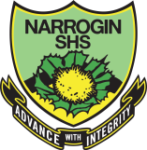
NARROGIN SENIOR HIGH SCHOOL
Address: | 45 Gray Street Narrogin WA 6312
Post: | Private Bag 2 Narrogin WA 6312
Telephone: | (08) 9881 9300
Email: | nshsmail@nshs.wa.edu.au
ABN | 44 318 707 628

PERMISSION SLIP FOR THE VIEWING OF NON-PRINT TEXTS

Dear Parent / Caregiver

As part of our curriculum in Health & Physical Education, your child will possibly be viewing a number of video clips that support teaching the curriculum. Your child’s class could be viewing non-print texts from the following classifications.

Classification:

(G) General, suitable for all ages

(PG) Parental Guidance Required for Students Under 15 Years of Age

(M 15+) Recommended for Mature Audiences 15 Years and Over

(MA 15+) Mature Accompanied (Restrictions apply to persons under 15)

(E) Educational, the program has not been classified according to the above as it has been produced solely for educational purposes

Department of Education policy requires parents/caregivers to be informed when non-print texts are shown and permission to be obtained for your child to view texts with this classification.

You have the right to withdraw your child from the viewing, in which case alternative work will be provided. The reason for showing these texts is that they convey information in an alternative way to that of the teacher. Computer graphics and real life examples, are examples of how non-print texts can form a valuable part of your child’s learning.

Would you please complete and return the permission slip below to your child’s Health teacher or Front Office ASAP. If the sheet is not returned your child will not be permitted to view non-print texts.

Thank you.

Andrew Corner
HOLA
Health and Physical Education

I _________________________________ give permission for my son / daughter
(Print Parent/Guardian Full Name)

___________________________________ to view all non-print texts that are provided during
(Print students full name)
Health Education lessons. I also understand that this permission is for the duration of the 2020 school year.

__________________________________ _____________
Parent/Guardian Signature Date
Advance with Integrity | Responsibility Respect Tolerance

