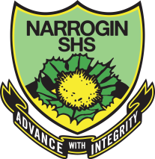
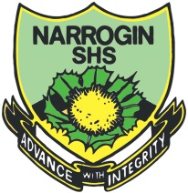
NARROGIN SENIOR HIGH SCHOOL

Address: | Gray Street Narrogin WA 6312
Post: | Private Bag 2 Narrogin WA 6312
Telephone: | (08) 9881 9300 Fax: (08) 9881 2170
Email: | nshsmail@nshs.wa.edu.au
ABN | 44 318 707 628

Dear Parent/Caregiver

Re: NAPLAN

The National Assessment Program – Literacy and Numeracy (NAPLAN) is an annual national assessment of all students in Years 3,5,7 and 9. All students are expected to participate in the testing. They will be assessed in language conventions (spelling, grammar and punctuation), writing and numeracy.

The NAPLAN tests are designed to complement the regular assessments made by teachers throughout the year.

The results support schools to identify strengths and weaknesses in teaching programs. State and territory departments of education gain information to help them evaluate programs and allocate resources.

NAPLAN tests are conducted at schools and administered by classroom teachers, school deputies or the principal.

The tests are scheduled for the mornings of:
Tuesday 9 May, Wednesday 10 May and Thursday 11 May 2017.

Wherever possible schools will organise another time between 9-12 May for individual students who are absent at the time of testing to complete missed tests. Students are not permitted to sit tests before or after these dates.

Sample questions can be accessed at nap.edu.au/naplan/the-tests on the national NAPLAN website.

The best way you can help your child prepare for NAPLAN is to reassure your child that NAPLAN tests are just one part of their school program and to urge them to simply do the best they can on the day.

Your child’s NAPLAN report will be issued through your school in mid-August.

You can get more information on the NAPLAN testing process from School Curriculum and Standards Authority website:
http:/k10outline.scsa.wa.edu.au/home/assessment/testing/naplan.

If you would like any more information please call the school on 98819300.

Yours sincerely

Ms Sandii Stankovic
Deputy – Middle School

28 April 2017

